Activity 2 Designing and Implementing a Custom Class

You have likely created a class from a given description or specification several times. This is an important skill, but equally important is the ability to determine essential information to include when creating a class. What is “essential” can vary based on perspective, or can be determined by a question that is being asked or a problem that is attempted to be solved. This activity will give you an opportunity to practice making this type of determination. Consider the following selection

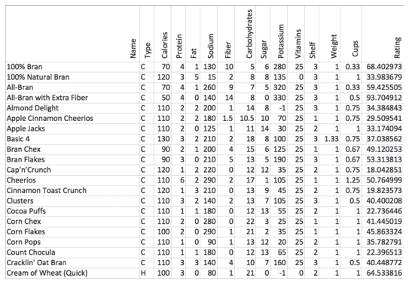

1. Each row of the table represents an instance of an object. What is the best name for that object?

|  |
| --- |

1. Your teacher will provide you with a question to answer related to the above table. Write the question here:

|  |
| --- |

1. You will now design a class to describe that object and answer your given question. Write the class header:

|  |
| --- |

1. How many instance variables will you create?

|  |
| --- |

1. List the data types and names you will use for the instance variables

|  |
| --- |

1. Create a new Java file named Cereal.java and implement the class described above. Your class should contain all necessary instance variables, constructors, accessors methods, and a toString method.

|  |
| --- |

1. Write a main method to test your Cereal class by implementing multiple instances of Cereal objects. This program should include lines instantiating Cereal objects.

|  |
| --- |

1. Given your class design, determine one additional question that you can answer without making any changes to Cereal.java.

|  |
| --- |

1. Identify one additional question that can be answered from the given data that you are not able to answer based on your implementation of Cereal.java.

|  |
| --- |

1. What modification could you make in order to answer this question?

|  |
| --- |